*Watch the following podcast on the* [*Chi Square Test*](http://www.bozemanscience.com/science-videos/2011/11/30/chi-squared-test.html) *and answer the questions that follow.*

1. What is the purpose of the Chi Squared test in science?
2. Using the formula, state what each variable represents.

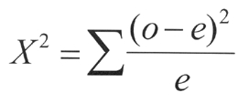

1. What does the null hypothesis state?
2. How is “degrees of freedom” determined?
3. What does it mean when you are using the alpha value .05 column in order to look up the critical value.
4. What does it mean if the chi square value is HIGHER than the critical value?
5. What does it mean if the chi square value is LOWER than the critical value?
6. Show ALL WORK to calculate the chi square test for the following problem:

You flip a coin a 100x. You get 55 heads and 45 tails.

1. State a null hypothesis for this scenario.
2. Calculate your chi square value.
3. State what we should do with our null hypothesis.
4. Explain whether the results are statistically significant or not.